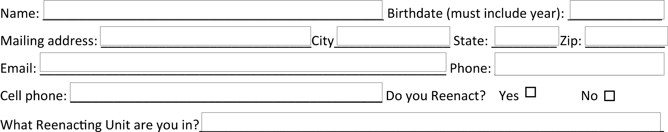

Annual fees are $10 per person or $20 for a family in the same household. Membership runs from Jan 1 through December 31. To join the Laurel Home Guard, fill out the blanks COMPLETELY (please print legibly) and mail the check or money order made out to Laurel Home Guard for the appropriate amount to James Cheek, 147 Sargent Branch Rd East, London Ky 40744. Thank you and welcome to the Laurel Home Guard!

